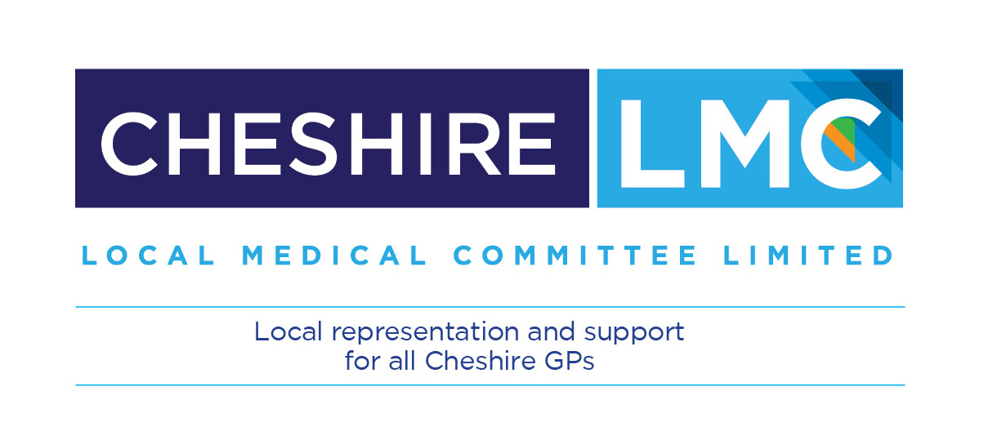

Cheshire Local Medical Committee Ltd

Investment and evolution:
A five-year framework for GP contract reform to implement The NHS Long Term Plan

Primary Care Networks: The Primary Care Network Agreement and Next Steps

A resource for 2019/20
Version 1: April 2019

Introduction
This advice has been developed and issued by Cheshire LMC. No part of the document or our interpretation supersedes the actual guidance or formal notes issued by NHS England. It is our intention to update our advice on our web site as the detailed instruction on various sections are released.

As always, we welcome your questions and will try to gain answers for you if the LMCs representatives do not have them readily to hand.

William Greenwood
Chief Executive
April 2019

The Network Agreement
The Network Agreement has now been published by NHSE. Participating practices who are forming Primary Care Networks (PCNs) need to submit various pieces of information to their CCGs by 15 May and 30 June.

A completed initial Network Agreement is the major part of these submissions and use of a national template is mandatory. In other words most of the sections cannot be amended. The Network Agreement must be finalised and signed by 30 June 2019, at the very latest.

What do we need to do by 15 May?
An initial submission of certain detail does not require the Network Agreement to be completed in its final form. By 15th the following is required:-

- Names of the member GP practices (in the front of the agreement)
- Details of the Network area, the Clinical Director and the nominated payee (schedule one of the agreement)
This should be the information practices will be currently discussing. From a legal point of view the most important decision at this stage will be the nominated payee, as this will identify who will receive the DES funding in the first instance and this could have significant tax, pension and control issues. You may wish to discuss this with your medical accountants.

What do we need to do by 30 June?
The full Network Agreement must be negotiated and signed by all PCN participants by 30 June. Additionally, all PCN practices must ensure they have in place a data sharing agreement and, if appropriate, data processor agreements. A national template for both of these items will be published soon.

Each PCN must inform the CCG that these documents are in place before the PCN will be considered as formally established. If this deadline is missed the PCN will not be able to start providing services, and any payments may be rebated.

What is contained in the Agreement?
The Agreement is a legally binding document. It is important that practices understand the rights and obligations which they are signing up to. There are four main sections.

Mandatory Fixed Clauses
These cannot be changed other than by direction from NHSE.
Mandatory Extendable Clauses
These clauses must apply, but can be added to with extra wording i.e. information sharing or the process for joining/ leaving the Network.
Replaceable Clauses
These are suggested default clauses, but can be modified or replaced entirely at the discretion of the PCN i.e. dispute resolution.
Locally Defined Clauses
PCNs can add their own clauses to the Agreement (so long as they do not conflict with other parts of the agreement). An example here might be limitations of liabilities as the basic document does not do this. Practices may not want to sign up without this sort of clause. You may need professional legal advice on this.

Do we need help to complete the Agreement?
Member practices can certainly fill in the information needed by 15 May and sign the template PCN Agreement un-amended plus the data sharing agreement once this is available. This can in particular work for very simple PCN structures. It may not be so suitable for other PCNs. Again, you may need some professional advice from your accountants and legal advisors.

Key information such as decision making and how revenue and costs will be allocated between members is very likely to be required. Agreements may not be easy to amend once signed. You may need to speak to your CCG about this and their approach to such actions.

The default position is that all subsequent changes must be agreed by everyone. Our understanding is that a single member could prevent the remaining members from making changes deemed appropriate once the PCN is operational. Again, some legal support around this issue might be money well spent.

As mentioned earlier the PCN Agreement is a legally enforceable document which will govern an increasing amount of the services to be provided by General Practice. The future direction and development of PCNs is still somewhat unclear in many respects and with that in mind it might be prudent to ensure you have flexibility in the replaceable and/or locally defined clauses. It is difficult to see how this can readily be addressed without involving some specialist accountant or legal help.

Such support could help in relation to tax, pension and legal implications both for the PCN and for the member practices. It is difficult to quantify this from an external viewpoint and much will depend on what you may already have in place from working at scale, Primary Care Home models or other local working arrangements. The LMC cannot advise you on this.
What are the next steps we can take?
In your initial discussions over the last few weeks you should have made some initial estimates of the potential Network income and likely costs (see the earlier LMC guide and PCN FAQ publications).

The BMA has also produced the PCN Handbook and ‘Top Tips’ for setting up a PCN.

There is less than four weeks before the first submission deadline and the limited amount of information must be submitted to your CCG (see the earlier section). Probably the most important issue is the nominated payee and appointment (election) of a Clinical Director. The payee issue may be the first point you require professional advice on.

The information required by 30 June is much more extensive and detailed. If you do choose to modify or expand the PCN Agreement template you may require specialist accountancy or legal support.

Many formative PCNs are now meeting on a regular basis and exploring many of the issues outlined in the schedules to the Agreement. The LMC has produced a slide pack which may help you structure some of your meeting agendas in the coming weeks.

We recommend you review the slides together with the BMA documents:-
- The Primary Care Network Handbook
- Primary Care Network Top Tips
- The LMCs FAQ documents.

Time Line for Primary Care Network Establishment

Date | Network DES Action
Jan-Apr 2019 | PCNs prepare to meet the Network Contract registration requirements
By 29 Mar 2019 | NHS England and GPC England jointly issue the Network Agreement and 2019/20 Network Contract
By 15 May 2019 | All Primary Care Networks submit expression of interest and initial registration information to their CCG
By 31 May 2019 | CCGs confirm network coverage and approve variation to GMS, PMS and APMS contracts
By 30 June | All Primary Care Networks submit mandatory registration details (schedules)
1 Jul 2019 | Network Contract goes live across 100% of the country
Jul 2019-Mar 2020 | National entitlements under the 2019/20 Network Contract start:  •year 1 of the workforce funding  •ongoing support funding for the Clinical Director  •ongoing £1.50/head from CCG allocations
Apr 2020 onwards | National Network Services start under the 2020/21 Network Contract

If you have any questions relating to the FAQs in this document please contact the LMCs Chief Executive WGreenwood@cheshirelmc.org.uk

Cheshire LMC is a member based organisation, independently funded by its member practices. It is the only representative voice in the local NHS that is recognised by statute.
We exist to represent and support you.

William Greenwood
Cheshire Local Medical Committee Ltd
The Weston Centre Weston Road
Crewe Cheshire
CW1 6FL
Tel: 01244 313 483
Email: WGreenwood@cheshirelmc.org.uk
Website: www.cheshirelmcs.org.uk
Twitter: coming soon
Issued April 2019 (final issue 1)

